Stacked Ensemble Model CNN and VGG16

Confusion Matrix

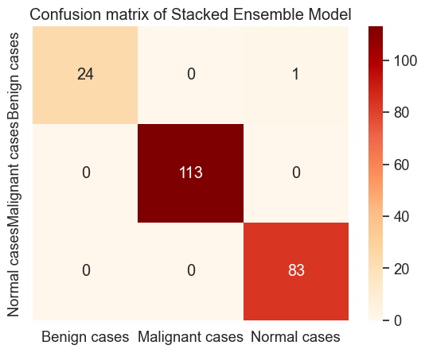

Classification Results

Stacked Ensemble Model Accuracy on Test Data: 99.55%

Precision Score: 0.995656108597285

Recall Score: 0.995475113122172

F1 Score: 0.9955077378717493

Classification report

precision recall f1-score support

0 0.96 1.00 0.98 24

1 1.00 1.00 1.00 113

2 1.00 0.99 0.99 84

accuracy 1.00 221

macro avg 0.99 1.00 0.99 221

weighted avg 1.00 1.00 1.00 221

Visualize Predictions

